The Society held three trials in the 2022/23 season, a novice and an open retriever trial at Checkley Wood Shoot by kind permission of Ivor Beavis; and a novice retriever trial at .Shawcroft Farm, Holmes Chapel by kind permission of John Wainwright.
The Society is extremely grateful to all the people who made the trials a success; the judges, volunteer helpers and especially the Guns who support the trials and help make them financially viable.
Unfortunately there were no spaniel trials this season due to a disastrous outbreak of bird flu at Checkley which meant that there were no birds in places suited to spaniel trials.

Novice AV Retriever trial, 3rd October 2022
Judges: Sean McGrath (A3010), Dawn Scott (B3643) Reuben Mort (NP2977) and Phil Goulden (NP3680)
The trial started by walking through a small field of cover crop, and then into a larger field of setaside. Birds came steadily to the Guns who shot well, providing the judges with some interesting retrieves for the dogs. The judges stretched the length of the retrieves as the trial progressed, with dogs being put out for failing to find or being eye wiped. Although there were some excellent dogs in the trial, on the last retrieve all four remaining dogs failed to find a cock pheasant 70 yards away and were eye-wiped by the judges.
There were no awards.

Open 24 dog Open AV Retriever trial 24th/25th October 2022
Judges: Jamie Bettinson (A2299) Steve Cullis (A2759) Paula Cullis (B2704) Craig Perry (B3550)

On both days the dogs were taken to stubble fields at the back of Checkley Wood and walked through open stubble fields, some fodder turnip and a large piece of gone to seed set aside. Dogs and handlers were given some testing retrieves, some long, some closer to the line, but with enough difficulty to leave 11 dogs for day two. The second day took the dogs along Checkley brook and out into another stubble field, giving some long and challenging retrieves. By lunchtime just five dogs remained and the judges declared the trial over.
First - Avonstream Aixinha handled by Greig Paterson
Second - Etomanni Missouri handled by Ronnie Laughton
Third - Wytonruss Finnigan handled by Ronnie Laughton
Fourth - Staverton Tarragon handled by Julia Reed
CoM - Bluecreek Curtis Cash owned by D Friedkin, handled by David Latham
Guns Choice - Burrendale Bruno handled by Tony O’Hare
Keeper’s Choice - Mistybrook Ochre handled by Kim Jinks
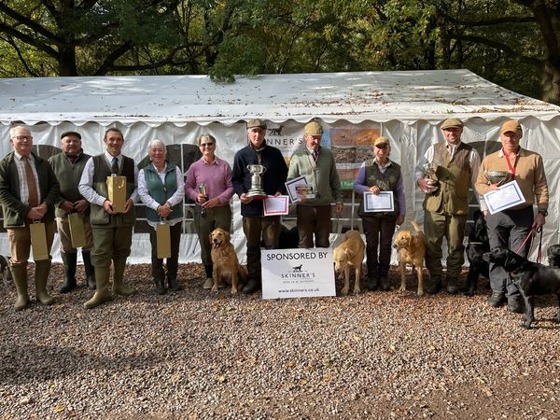

Novice AV Retriever Trial,26th January at Shawcroft Farm, Holmes Chapel, by kind permission of Mr John Wainwright.
Judges: David Latham (A2299), David Jackson (A1881), Louise Munchaus-Adsboel (NP) and
Sharon Kitson (NP).
This was the first time a trial had been held at the ground, and what a spectacular venue it proved to be. It was a driven trial and the Guns shot extremely well, giving the judges a variety of retrieves on open fields, across a stream and into woodland with which to test the dogs. After losing dogs for running in, not finding game, squeaking and other eliminating faults, the judges awarded the following:

First- Phil Goulden with Turpingreen Espinoza
Second - Alan Rees with Jocksburn Mackey at Delfryd
CoM - Vikki Stanley with Minstead Reacher.
Phil was awarded the Society’s new trophy, the Dennis Heath Trophy, which is to honour all the hard work Dennis has put into the club over many years of service as treasurer.

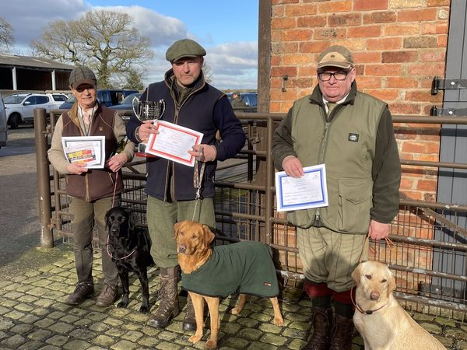

The Society hopes to hold retriever and spaniel trials next season, but the shadow of bird flu still hangs heavy upon us. Fingers are crossed for a trouble free and successful trialling season.

